**1. WEBSITE FOR YOUR COLLEGE**

**1.**

<html>

<head>

<title>MY CREATION</title>

<body text="blue">

<h1><u><center>GOVERMENT OF ARTS AND SCIENCE COLLEGE</center></u></h1>

<h2><u><center>KANGEYAM-638 701</center></u></h2><br>

<h2><u><center>COURSES OFFERED</center></u></h2>

<h2><u>UG COURSES</u></h2><h2><u><center>PG COURSES</center></u></h2>

<h2><a href="detail.html">Computer science</a></h2><h2><center><a href="detail.html">Computer science</center></a></h2>

<h2><a href="com.html">Commerce</a></h2><h2><center><a href="com.html">Commerce</center></a></h2>

<h2><a href="tamil.html">Tamil</a></h2><h2><center><a href="tamil.html">Tamil</center></a></h2>

<h2><a href="english.html">English</a></h2><h2><center><a href="english.html">English</center></a></h2>

<h2><a href="bba.html">BBA</a></h2><h2><center><a href="bba.html">BBA</center></a></h2>

</body>

</head>

</html>

**2.**

<html>

<head>

<title>computer science</title>

<h1><u><center>DEPATEMENT OF COMPUTER SCIENCE</center></u></h1>

<h2>UG Student details</h2><h2><center>PG Student details</center></h2>

<h3>No Of First year student is 40</h3><h3><center>No Of First year student is 35</center></h3>

<h3>No Of Second year student is 35</h3><h3><center>No Of Second year student is 40</center></h3>

<h3>No Of Third year student is 45</h3>

<h2><center>THE NO OF STAFF MEMBERS</center></h2>

<h3><center>T.RAJENDRAN MCA.,M.PHIL.,PHD.,</h3></center>

<h3><center>S.SATHYA MCA.,M.PHIL.,PHD.,</h3></center>

</head>

</html>

**3.**

<html>

<head>

<title>commerce</title>

<h1><u><center>DEPATEMENT OF COMMERCE</center></u></h1>

<h2>UG Student details</h2><h2><center>PG Student details</center></h2>

<h3>No Of First year student is 45</h3><h3><center>No Of First year student is 40</center></h3>

<h3>No Of Second year student is 40</h3><h3><center>No Of Second year student is 45</center></h3>

<h3>No Of Third year student is 45</h3>

<h2><center>THE NO OF STAFF MEMBERS</center></h2>

<h3><center>K.KAVITHA M.COM.,M.PHIL.,S.L.E.T.,M.B.A.,PGDCA.,PHD.,</h3></center>

<h3><center>M.VIDHYA M.COM(CA).,S.L.E.T.,M.B.A.,PGDCA.,PHD.,</h3></center>

</head>

</html>

**4.**

<html>

<head>

<title>tamil</title>

<h1><u><center>DEPATEMENT OF TAMIL</center></u></h1>

<h2>UG Student details</h2><h2><center>PG Student details</center></h2>

<h3>No Of First year student is 40</h3><h3><center>No Of First year student is 35</center></h3>

<h3>No Of Second year student is 35</h3><h3><center>No Of Second year student is 40</center></h3>

<h3>No Of Third year student is 45</h3>

<h2><center>THE NO OF STAFF MEMBERS</center></h2>

<h3><center>R.CHANDRASEKARAN M.A.,M.A.,M.A.,M.A.,M.PHIL.,PHD.,PHD.,</h3></center>

<h3><center>V.PANNERSELVAM M.A.,M.PHIL.,PHD.,</h3></center>

</head>

</html>

**5.**

<html>

<head>

<title>English Depatement</title>

<h1><u><center>DEPATEMENT OF ENGLISH</center></u></h1>

<h2>UG Student details</h2><h2><center>PG Student details</center></h2>

<h3>No Of First year student is 45</h3><h3><center>No Of First year student is 40</center></h3>

<h3>No Of Second year student is 30</h3><h3><center>No Of Second year student is 35</center></h3>

<h3>No Of Third year student is 40</h3>

<h2><center>THE NO OF STAFF MEMBERS</center></h2>

<h3><center>R.SIVASAMY M.A.,N.E.T.,</h3></center>

<h3><center>P.DEVEKI M.A.,M.PHIL.,PHD.,</h3></center>

</head>

</html>

**6.**

<html>

<head>

<title>BBA Depatement</title>

<h1><u><center>DEPATEMENT OF BBA</center></u></h1>

<h2>UG Student details</h2><h2><center>PG Student details</center></h2>

<h3>No Of First year student is 30</h3><h3><center>No Of First year student is 25</center></h3>

<h3>No Of Second year student is 35</h3><h3><center>No Of Second year student is 30</center></h3>

<h3>No Of Third year student is 35</h3><h3>

<h2><center>THE NO OF STAFF MEMBERS</center></h2>

<h3><center>K.KOMARASAMY M.B.A.,M.PHIL.,PHD.,PGDCA.,PGDPM&LL</h3></center>

</head>

</html>

**OUTPUT:**

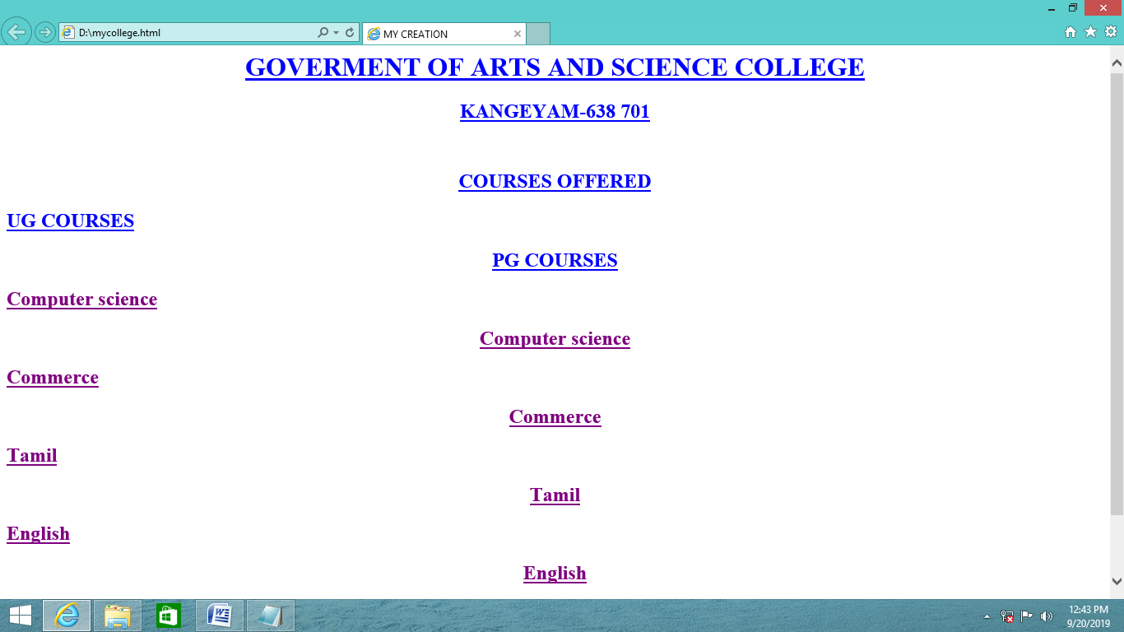

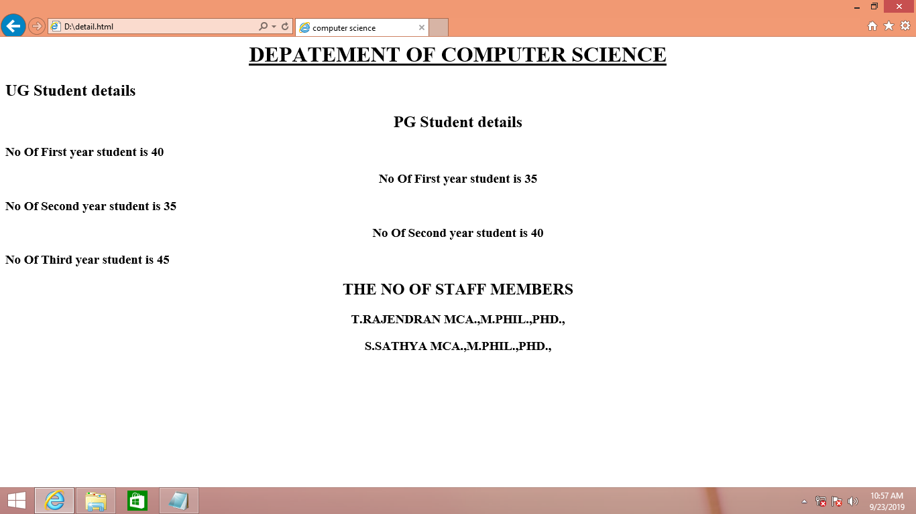

**2. LIST OF COUNTRIES**

**WORLD:**

<!DOCTYPE html>

<!--

To change this license header, choose License Headers in Project Properties.

To change this template file, choose Tools | Templates

and open the template in the editor.

-->

<html>

<head>

<title>WORLD</title>

</head>

<body bgcolor="pink">

<center>

<h2>LIST OF COUNTRIES</h2><br><br>

<img src="world.gif" width="200" height="200">

<h3>

<ul>

<li><a href="India.html" target="t3">India</a></li><br>

<li><a href="Australia.html" target="t3">Australia</a></li><br>

<li><a href="London.html" target="t3">London</a></li><br>

</ul>

</h3>

</center>

</body>

</html>

**INDIA:**

<!DOCTYPE html>

<!--

To change this license header, choose License Headers in Project Properties.

To change this template file, choose Tools | Templates

and open the template in the editor.

-->

<html>

<head>

<title>INDIA</title>

</head>

<body bgcolor="green">

<center>

<h2 style="fontsize40pt">

<u><b>Welcome to my country</b></u>

</h2>

<img src="india.jpg" width="200" height="200" align="left">

</center>

<h3 align="right"></h3>

<center>

<p><br>India is known as the republic of india it is a country in south asia.<br>

It is a country in south Asia.It is the south asia.<br>

It is the seventh largest country by area.<br>

It is bounded by the indian ocean on the south,<br>

the arabian sea on southwest,the bay of bengal on the southeast

</p>

</center>

</body>

</html>

**AUSTRALIA:**

<!DOCTYPE html>

<!--

To change this license header, choose License Headers in Project Properties.

To change this template file, choose Tools | Templates

and open the template in the editor.

-->

<html>

<head>

<title>AUSTRALIA</title>

</head>

<body bgcolor="skyblue">

<center>

<h1 style="fontsize40pt">

<u><b>Welcome to my country</b></u>

</h1>

<img src="australia.jpg" width="200" height="200" align="left">

</center>

<h3 align="right"></h3>

<center>

<p><br> Australia officially the commonurath of country is a servereign,<br>

country comprising the mainland of the australian contiment,<br>

the island of tasmania and numberous smaller island.<br>

It is the largest country in oceain and the world's sixth largest country by total area.

</p>

</center>

</body>

</html>

**LONDON:**

<!DOCTYPE html>

<!--

To change this license header, choose License Headers in Project Properties.

To change this template file, choose Tools | Templates

and open the template in the editor.

-->

<html>

<head>

<title>LONDON</title>

</head>

<body bgcolor="yellow">

<center>

<h2 style="fontsize20pt">

<u><b>welcome to my country</u></b>

</h2>

<img src="london.jpg" width="300" height="300" align="left">

</center>

<h3 align="right"></h3>

<center>

<p><br><br>london is next to europe it's a second largest countries with a population<br>

is roman province of britain's captial by city.Thus from the enter of the <br>

british empire in london the UK's gross domastic product(GDP).<br>

Its contribution to it is the fourth largest country by total area.

</p>

</center>

</body>

</html>

**CHINA:**

<!DOCTYPE html>

<!--

To change this license header, choose License Headers in Project Properties.

To change this template file, choose Tools | Templates

and open the template in the editor.

-->

<html>

<head>

<title>CHINA</title>

</head>

<body background ="china.jpg">

<center>

<h2 style="fontsize20pt">

<u><b>welcome to my country</u></b>

</h2>

<img src="china.png" width="200" height="200" align="left">

</center>

<h1 align="right"></h1>

<center>

<p><br><br>China,officially the People's Republic of China,<br>

is a country in East Asia and the world's most populous country,<br>

with a population of around 1.404 billion.<br>

It is the third or fourth largest county by total area.

</p>

</center>

</body>

</html>

**PAKISTAN:**

<!DOCTYPE html>

<!--

To change this license header, choose License Headers in Project Properties.

To change this template file, choose Tools | Templates

and open the template in the editor.

-->

<html>

<head>

<title>PAKISTAN</title>

</head>

<body background ="pakistan.jpg">

<center>

<h2 style="fontsize20pt">

<u><b>welcome to our country</u></b>

</h2>

<img src="pak.jpg" width="200" height="200" align="left">

</center>

<h1 align="right"></h1>

<center>

<p><br><br>Pakistan ,officially the lslamic Republic of pakistan,<br>

is the country in south Asia.It is the world's sixth-most populous country,<br>

with a poulation exceeding 211,742,631 people .<br>

In area,it is the 33rd-largest country,spanning 881,913 square kilometers.

</p>

</center>

</body>

</html>

**OUTPUT:**

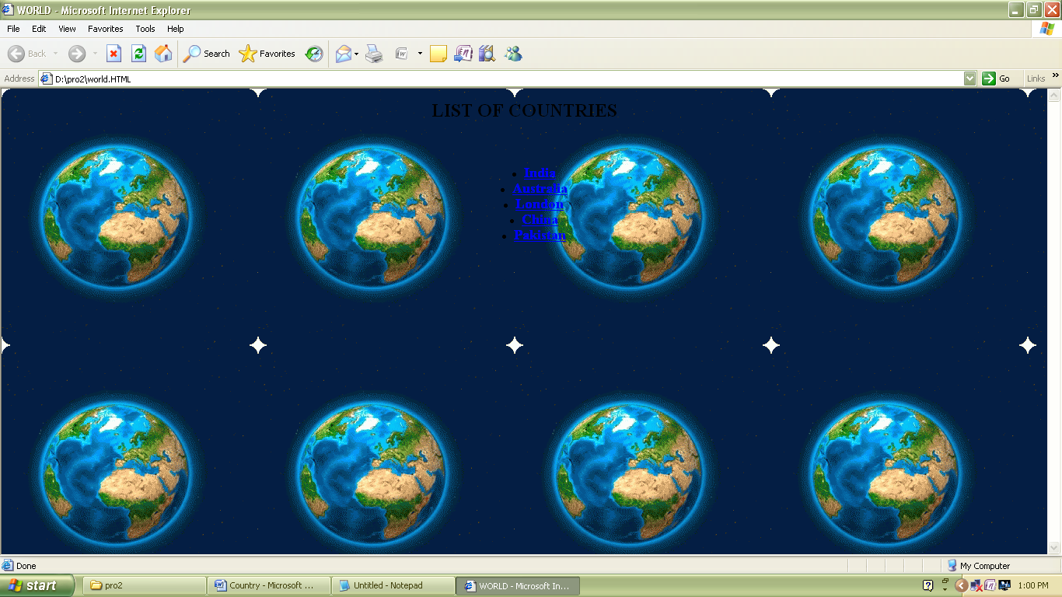

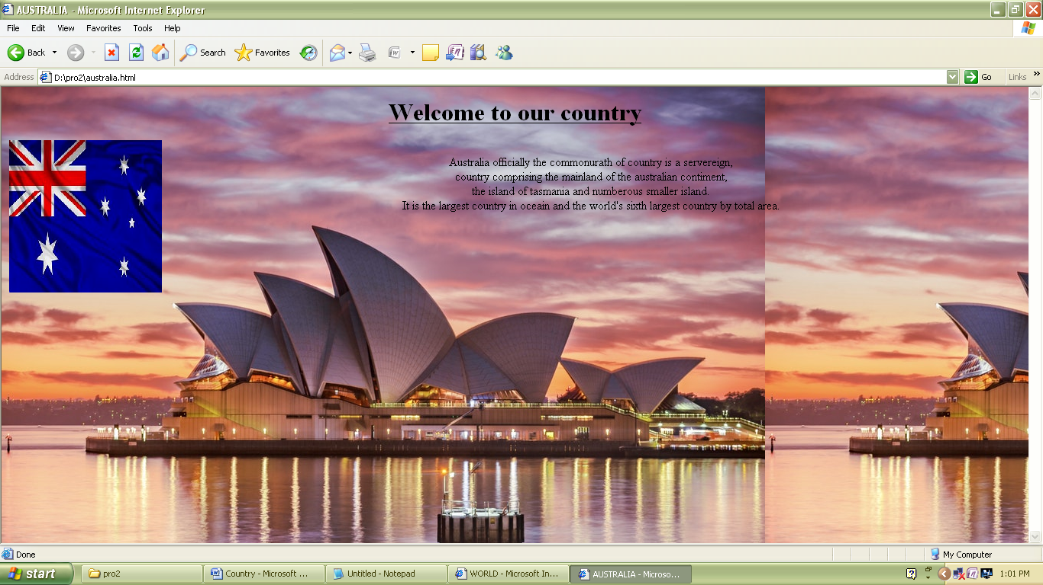

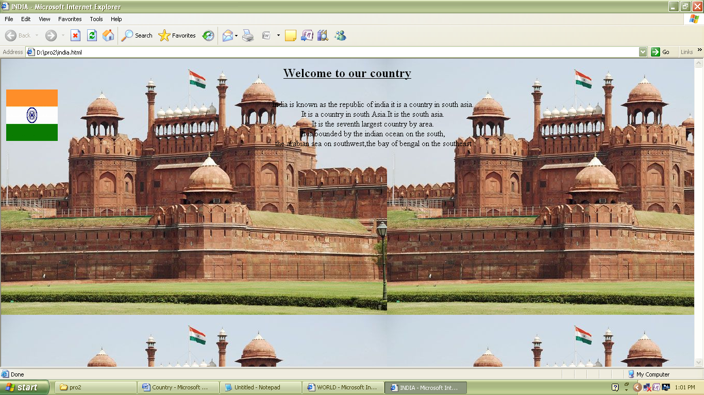

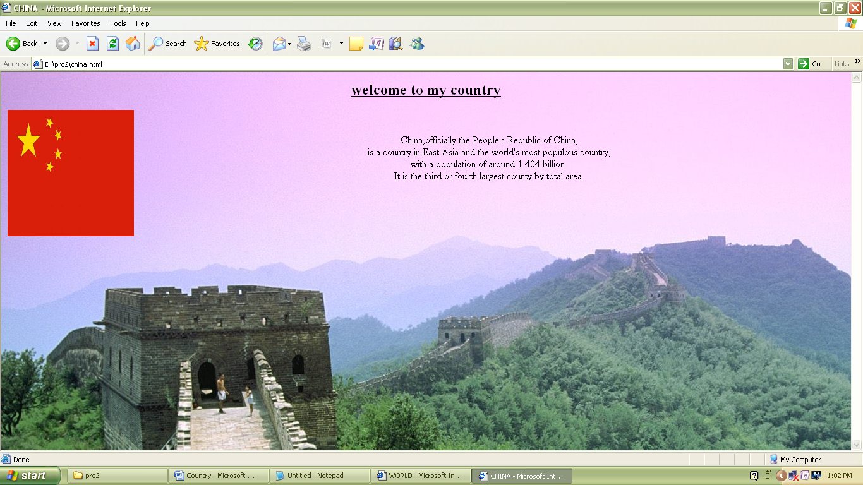

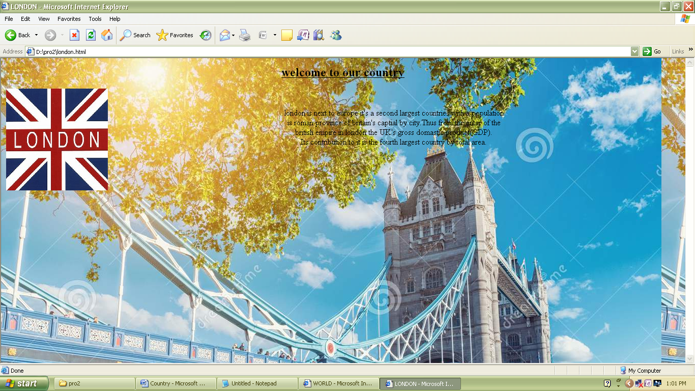

**3. a) BULLETS/NUMBER USING LISTS**

<HTML>

<HEAD>

<TITLE>

USING BULLETS IN HTML

</TITLE>

</HEAD>

<BODY bgcolor="pink">

<H1><U><CENTER>DISPLAY TEXT WITH BULLETS & NUMBER USING LIST</CENTER></U></H1>

<H1><U>USING BULLETS</U></H1>

<h1>what is xml?</h1>

<li>Extensible Markup Language(XML) is a markup language that defines a set of rules for encoding documents in a format that is both human-readable and machine readable.</li>

<li>It is a textual data format with strong support via unicode for different human language.</li>

<BR>

<menu>

<h1>using square bullets</h1>

<li type="square">Python</li>

<li type="square">c++</li>

<li type="square">Java</li>

<li type="square">C</li>

<li type="square">Cobal</li>

</menu>

<BR>

<BR>

<BR>

<h1><U>USING NUMBERS</U></H1>

<h1>what is xml?</h1>

<ol type="1">

<li>Extensible Markup Language(XML) is a markup language that defines a set of rules for encoding documents in a format that is both human-readable and machine readable. </li>

<li>It is a textual data format with strong support via unicode for different human language.</li>

<BR>

<BR>

</ol>

<ol type="i">

<li>Python</li>

<li>C++</li>

<li>C</li>

<li>Java</li>

<li>Cobal</li>

</ol>

<BR>

<BR>

<ol type="I">

<li>HTML</li>

<li>XML</li>

<li>SOAP</li>

<li>WSDL</li>

<li>UDDI</li>

</ol>

<!DOCTYPE html>

</html>

</head>

**OUTPUT:**

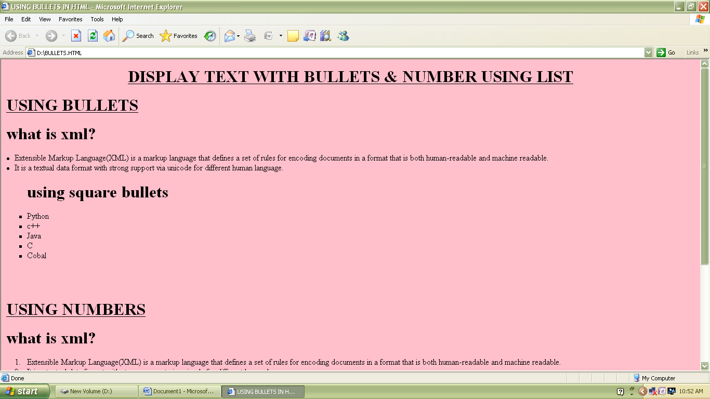

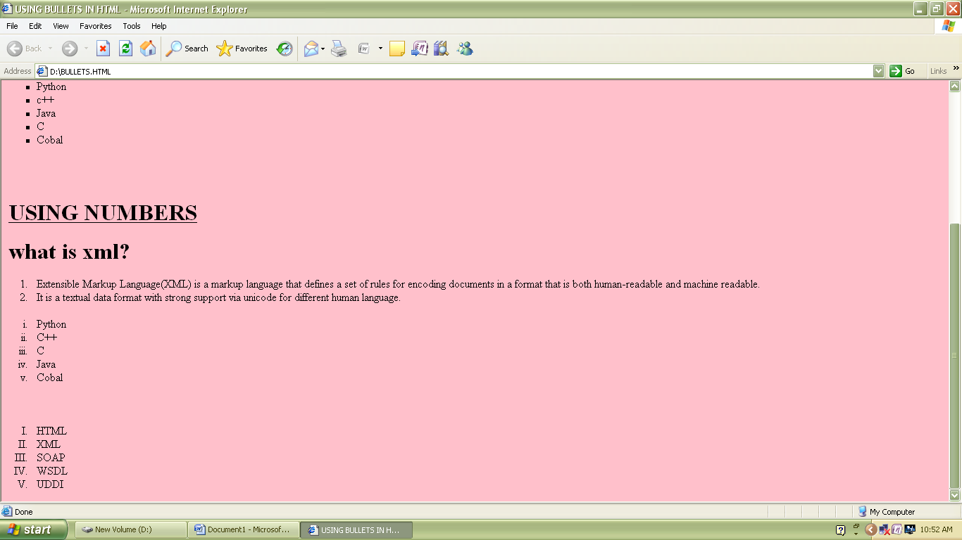

**B). DISPLAY THA TABLE FORMAT**

<HTML>

<HEAD>

<TITLE>

USING TABLES IN HTML

</TITLE>

</HEAD>

<BODY bgcolor="yellow">

<H1><U><CENTER> GOVERNMENT ARTS AND SCIENCE COLLEGE</CENTER></U></H1>

<H1><U><CENTER>DEPARTMENT OF COMPUTER SCIENCE</CENTER></U></H1>

<style>

table,th,td{

border:1px solid black;

border-collapse:collapse

}

</style>

</head>

</html>

<table style="width:100?">

<tr>

<th>S.No</th>

<th>Register No</th>

<th>Student Name</th>

<th>Web Service</th>

<th>Python Program</th>

<th>Business Intelligence</th>

<th>Network Security &Crytography</th>

<th>Digital Image Processing</th>

</tr>

<tr>

<td>01</td>

<td>1832K0514</td>

<td>M.Deivanai</td>

<td> 90 </td>

<td>80</td>

<td>95 </td>

<td>85</td>

<td>90 </td>

</tr>

<tr>

<td>02</td>

<td>1832K0515</td>

<td>S.Gayathri</td>

<td>90 </td>

<td>80</td>

<td>95 </td>

<td>85</td>

<td>90 </td>

</tr>

<tr>

<td>03</td>

<td>1832K0516</td>

<td>S.Jaganathan</td>

<td>90 </td>

<td>80</td>

<td>95 </td>

<td>85</td>

<td>90 </td>

</tr>

<tr>

<td>04</td>

<td>1832K0517</td>

<td>M.JamunaRani</td>

<td>90 </td>

<td>80</td>

<td>95 </td>

<td>85</td>

<td>90 </td>

</tr>

<tr>

<td>05</td>

<td>1832K0518</td>

<td>C.Jancy Priyanka</td>

<td>90 </td>

<td>80</td>

<td>95 </td>

<td>85</td>

<td>90 </td>

</tr>

<tr>

<td>06</td>

<td>1832K0519</td>

<td>S.Kalaiyarasi</td>

<td> 90 </td>

<td>80</td>

<td>95 </td>

<td>85</td>

<td>90 </td>

</tr>

<tr>

<td>07</td>

<td>1832K0520</td>

<td>R.Kasturi</td>

<td> 90 </td>

<td>80</td>

<td>95 </td>

<td>85</td>

<td>90 </td>

</tr>

<tr>

<td>08</td>

<td>1832K0521</td>

<td>S.Kowsalya</td>

<td> 90 </td>

<td>80</td>

<td>95 </td>

<td>85</td>

<td>90 </td>

</tr>

<tr>

<td>09</td>

<td>1832K0522</td>

<td>S.Lakshmana Kumar</td>

<td> 90 </td>

<td>80</td>

<td>95 </td>

<td>85</td>

<td>90 </td>

</tr>

<tr>

<td>10</td>

<td>1832K0523</td>

<td>P.Madhan Kumar</td>

<td> 90 </td>

<td>80</td>

<td>95 </td>

<td>85</td>

<td>90 </td>

</tr>

<tr>

<td>11</td>

<td>1832K0524</td>

<td>J.Nivetha</td>

<td> 90 </td>

<td>80</td>

<td>95 </td>

<td>85</td>

<td>90 </td>

</tr>

<tr>

<td>12</td>

<td>1832K0525</td>

<td>N.Ragavan</td>

<td> 90 </td>

<td>80</td>

<td>95 </td>

<td>85</td>

<td>90 </td>

</tr>

<tr>

<td>13</td>

<td>1832K0526</td>

<td>N.Rajeev</td>

<td> 90 </td>

<td>80</td>

<td>95 </td>

<td>85</td>

<td>90 </td>

</tr>

<tr>

<td>14</td>

<td>1832K0527</td>

<td>G.Ramya</td>

<td> 90 </td>

<td>80</td>

<td>95 </td>

<td>85</td>

<td>90 </td>

</tr>

<tr>

<td>15</td>

<td>1832K0528</td>

<td>M.SivaSankar</td>

<td> 90 </td>

<td>80</td>

<td>95 </td>

<td>85</td>

<td>90 </td>

</tr>

</table>

</body>

</html>

**OUTPUT:**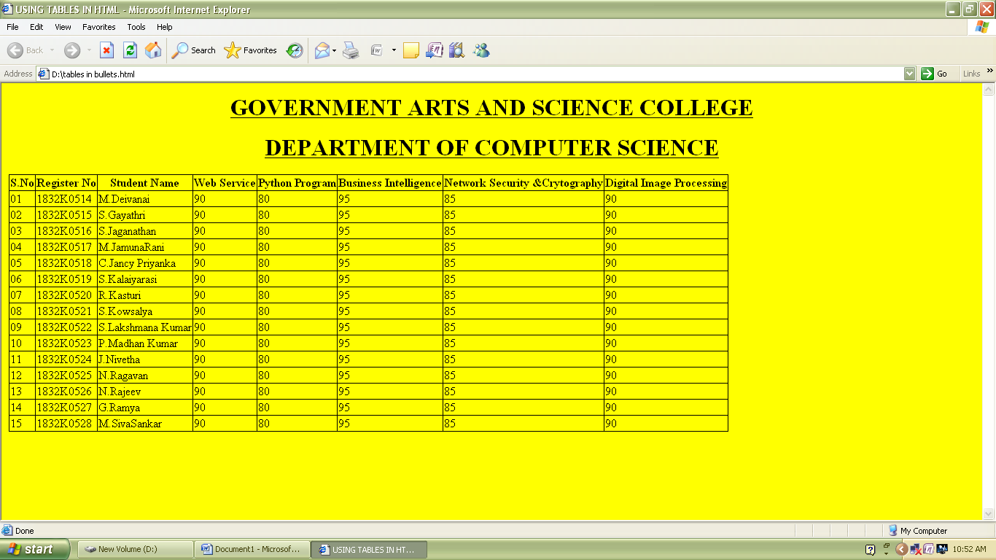

**4. HOSPITAL DETAILS USING IN FRAMESETS**

1

.

<html>

<head>

<title>Hospital Details</title>

</head>

<body>

<h1><center><u>GOVERNMENT HOSPITAL</u></center></h1>

<ul>

<li><a href="red.html"target="frm">ADDRESS</a></li>

<li><a href="blue.html"target="frm">CONTACTS </a></li>

<li><a href="black.html"target="frm">WORKING HOUS</a></li>

</ul>

</body>

</html>

2.

<html>

<head>

<title>red</title>

</head>

<body bgcolor="red">

<img src="im1.jpg" alt="im1" align="right" height="590" width="630">

<h1><u><center>ARIGNAR ANNA GOVT.HOSPITAL</u></center><h1>

<h2><u>ADDRESS</u></h2>

<h3>Poonamallee High RoadArumbakkam,</h3>

<h3>Landmark: Near Anna Arch</h3>

</h3>cheenai - 600106</h3>

</head>

</html>

3.

<html>

<head>

<title>blue</title>

</head>

<body bgcolor="blue">

<img src="im4.jpg" alt="im4" align="right" height="590" width="630">

<h1><u><center>ARIGNAR ANNA GOVT.HOSPITAL</u></center><h1>

<h2><u>CONTACTS</u></h2>

<h2>1.108</h2>

<h2>2.044 0621 4844</h2>

</head>

</html>

4.

<html>

<head>

<title>black</title>

</head>

<body bgcolor="yellow">

<h1><u><center>ARIGNAR ANNA GOVT.HOSPITAL</u></center><h1>

<h2>Working Hours</h2>

<h3>Monday - Sunday : 24 Hrs</h3>

<h3>Monday - Sunday : 24 Hrs</h3>

</head>

</html>

5.

<html>

<head>

<title>frame</title>

<frameset rows="25%,25%,25%,25%">

<frame src="hospital.html">

<frame src="red.html">

<frame src="blue.html">

<frame src="black.html">

</head>

</html>

**OUTPUT:**

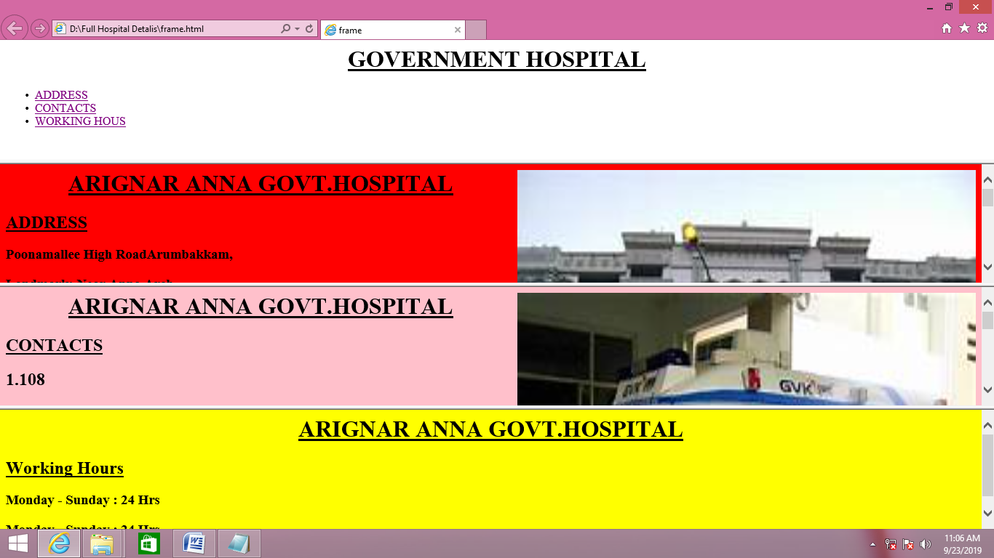

**5. BIO DATA**

<!DOCTYPE html>

<!--

To change this license header, choose License Headers in Project Properties.

To change this template file, choose Tools | Templates

and open the template in the editor.

-->

<html>

<head>

<title>BIO DATA</title>

</head>

<body bgcolor="skyblue" text="blue">

<center><table border="6" width="80%"></center>

<caption><h3><i>BIODATA</i></h3></caption>

<tr><td>NAME<td align="left" colspan="4">ARUNA

<tr><td>RELIGION<td align="left" colspan="6">HINDU

<tr><td>COMMUNITY<td align="left" colspan="6">BC

<tr><th align="left" colspan="12">ADDRESS

<tr><td>STREET<td align="left" colspan="13">SAMUNDIPURAM

<tr><td>TOWN<td align="left" colspan="13">TIRUPPUR

<tr><td>STATE<td align="left" colspan="13">TAMILNADU

<tr><td>MOBILE<td align="left" colspan="13">9999999999

<tr><th align="left" colspan="20">EDUCATIONAL QUALIFICATION

<tr><th>DEGREE<th>UNIVERSITY BOARD<th>MONTH & YEAR<th>GRADE</th>

<tr><td><center>MSC</center>

<td><center>BHARATHIYAR UNIVERSITY</center>

<td><center>APRIL 2020</center>

<td><center>82</center>

<tr><td><center>BSC</center>

<td><center>BHARATHIYAR UNIVERSITY</center>

<td><center>APRIL 2018</center>

<td><center>76</center>

<tr><td><center>HSC</center>

<td><center>STATE BOARD</center>

<td><center>APRIL 2015</center>

<td><center>72</center>

<tr><td><center>SSLC</center>

<td><center>STATE BOARD</center>

<td><center>APRIL 2013</center>

<td><center>78</center>

</table>

</body>

</html>

**OUTPUT:**

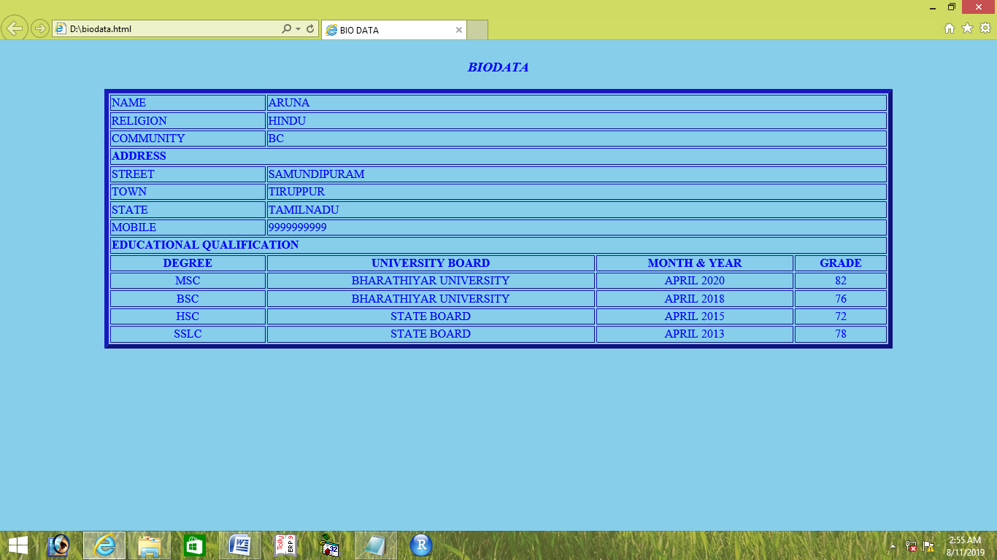

**6. REGISTRATION FORM DISPLAY**

<html>

<head>

<title>REGISTRATION FORM</title>

</head>

<body bgcolor="skyblue">

<center>

<p><h1>GOVERNMENT ARTS AND SCIENCE COLLEGE,KANGEYAM</h1>

<h2>Afflicated to bharthiyar university</h2>

<h2>Department of computer science<br>

<h2><b><u>REGISTRATION FORM</u></h2></center>

<form id="login" action="index" method="">

<input type="text" placeholder="student name" class="radius"/><br/><br/>

<input type="text" placeholder="college name" class="radius"/><br/><br/>

<input type="text" placeholder="Mobile number" class="radius1"/><br/><br/>

<input type="text" placeholder="Email id" class="radius"/><br/><br/>

<select name="year" class="radius"><option>select course</option><option>B.tech</option>

<option>B.sc</option><option>B.Arch</option><option>M.sc</option><option>M.C.A</option></select><br/><br/>

select your skills<br/>

<input type="checkbox">Debugging<br/>

<input type="checkbox">word hunt<br/>

<input type="checkbox">Paper presentation<br/>

<input type="checkbox">Quiz<br/>

<input type="radio" name="gender"/>Male<input type="radio" name="gender"/>Female<br/>

</h4>Place:<br>date:<br>

<h4 align="right">Signature of the prinicipal & HOD<br>(with seal)</h4>

</body>

</html>

**OUTPUT:**

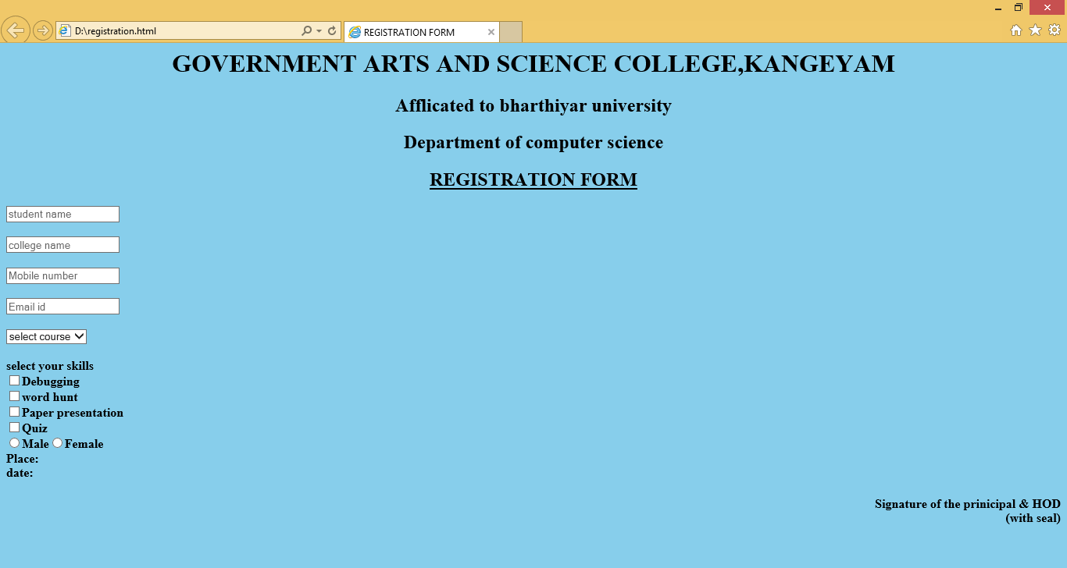

**7.** **CUSTOMER DETAILS**

<html>

<head>

<title>

CUSTOMER DETAILS

</title>

</head>

<body bgcolor=" light blue">

<H1><CENTER><MARK><U>CUSTOMER DETAILS</CENTER><MARK></U></H1>

<?PHP

?>

<from>

<table>

<tr>

<td>

Name:

</td>

<td>

<input type="Name" placeholder="Name" name="">

<?php if(isset($name)){echo $name;}?>

<?php if(isset($code) && $code=1)

{echo "class=errormsg";} ?></td>

</td>

<tr>

</tr>

<td>

City:

</td>

<td>

<input type="City"placeholder="City" name="">

<?php if(isset($name)){echo $name;}?>

<?php if(isset($code) && $code=1)

{echo "class=errormsg";} ?></td>

</td>

<tr>

</tr>

<td>

Pincode:

</td>

<td>

<input type="Pincode"placeholder="Pincode" name="">

<?php if(isset($pincodde)){echo $pincode;}?>

<?php if(isset($code) && $code=3)

{echo "class=errormsg";} ?></td>

</td>

</tr>

<tr>

<td>

PhoneNumber:

</td>

<td>

<input type="Phonenumber"placeholder ="Phonenumber" name="">

<?php if(isset($number)){echo $number;}?>

<?php if(isset($code) && $code=4)

{echo "class=errormsg";} ?> </td>

</td>

</tr>

<tr>

<td>

Email add:

</td>

<td>

<input type="Emailadd"placeholder="Emailadd" name="">

<?php if(isset($email)){echo $email;}?>

<?php if(isset($code) && $code=5)

{echo "class=errormsg";} ?> </td>

</td>

<tr>

</tr>

<td><button type="submit">submit</button>

</td>

</table>

</form>

</boby>

</head>

</html>

**OUTPUT:**

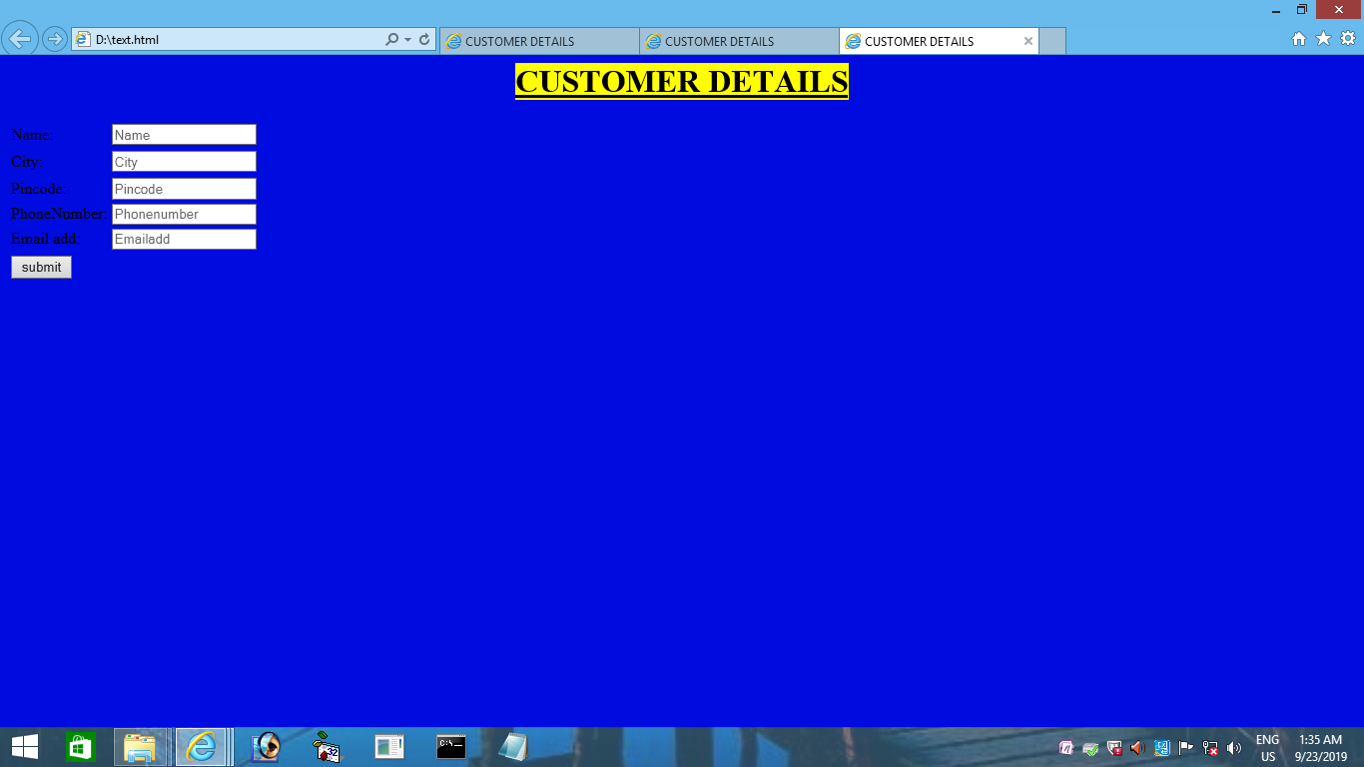

**8. PRIME NUMBER**

<html>

<head>

<title>

PRIME NUMBER

</title>

<head>

<body bgcolor="sky blue" >

<h1><center>prime number</center></h1>

<form action="/D:/submit.php" "method="get">

<br><h3>n1.<input type="text"name="n1"></h3>

<br><h3>n2.<input type="text"name="n2"></h3>

<button type="submit">submit</button>

<br>

</form>

</html>

**PHP CODE :-**

<?php

$number=2;

while($number<100)

{

$div_count=0;

for($i=1;$i<=number;$i++)

{

if(($number%$i)==0)

{

$div_count++;

}

}

if($div_count<3)

{

echo $number.",";

}

$number=$number+1;

}

?>

**OUTPUT:**

